U18CO018

Shubham Shekhaliya

Assignment-2 (CN)

WIRESHARK ASSIGNMENT

**1 Carefully read the lab instructions and finish all tasks.**

**5 Using Wireshark to capture the FTP password.**

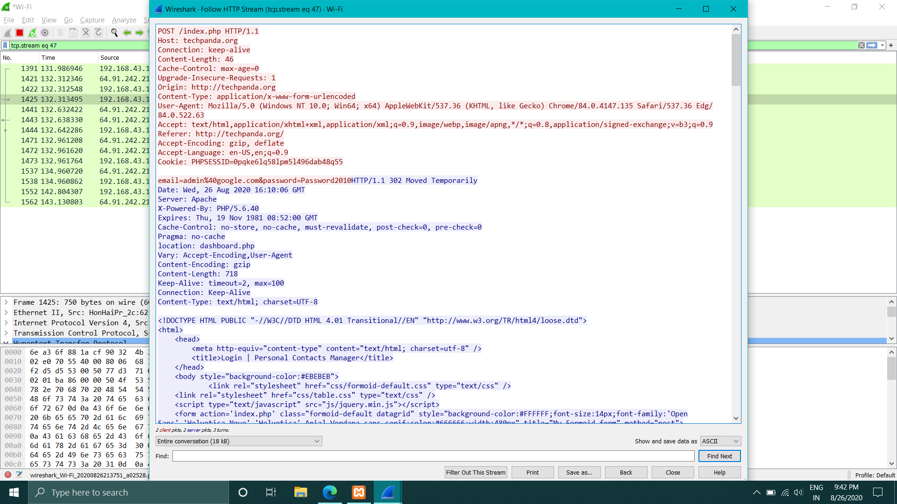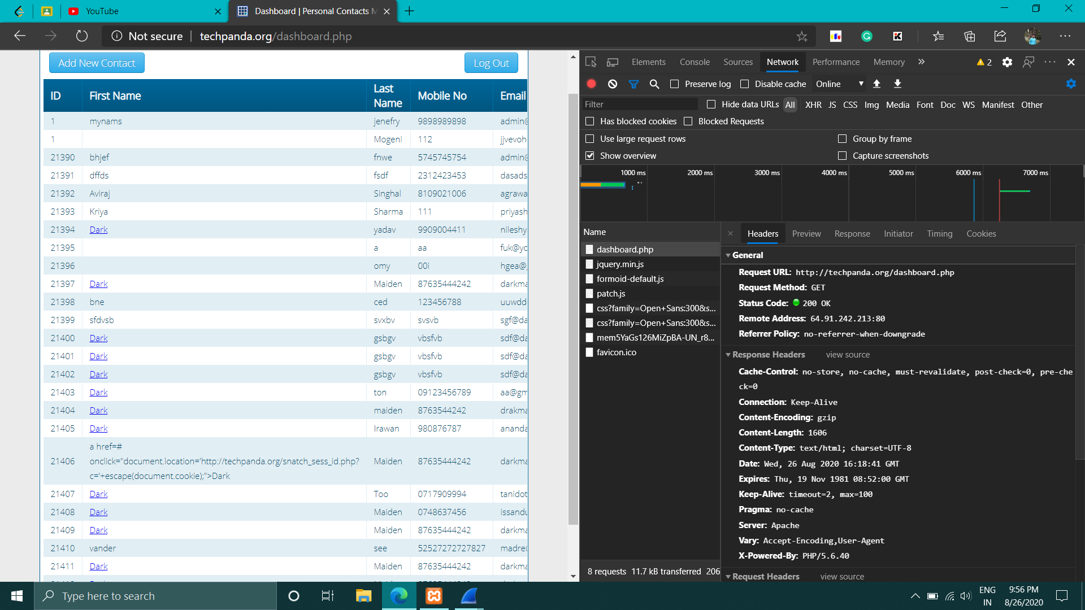

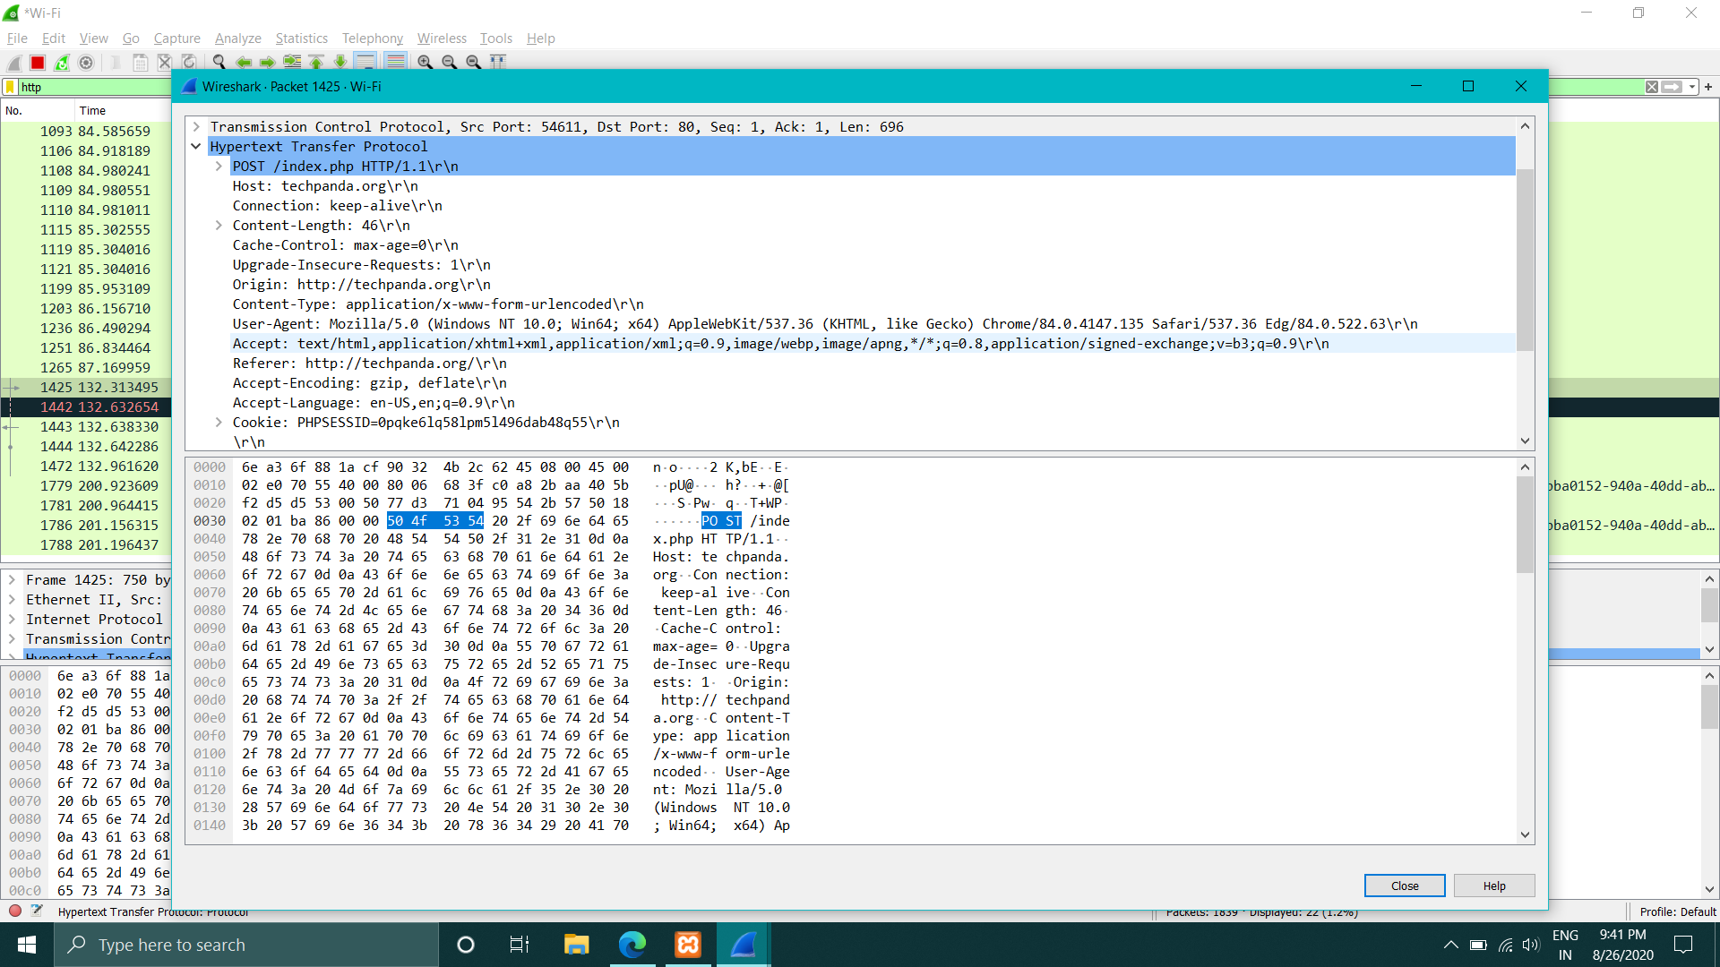

**UDP Protocol**

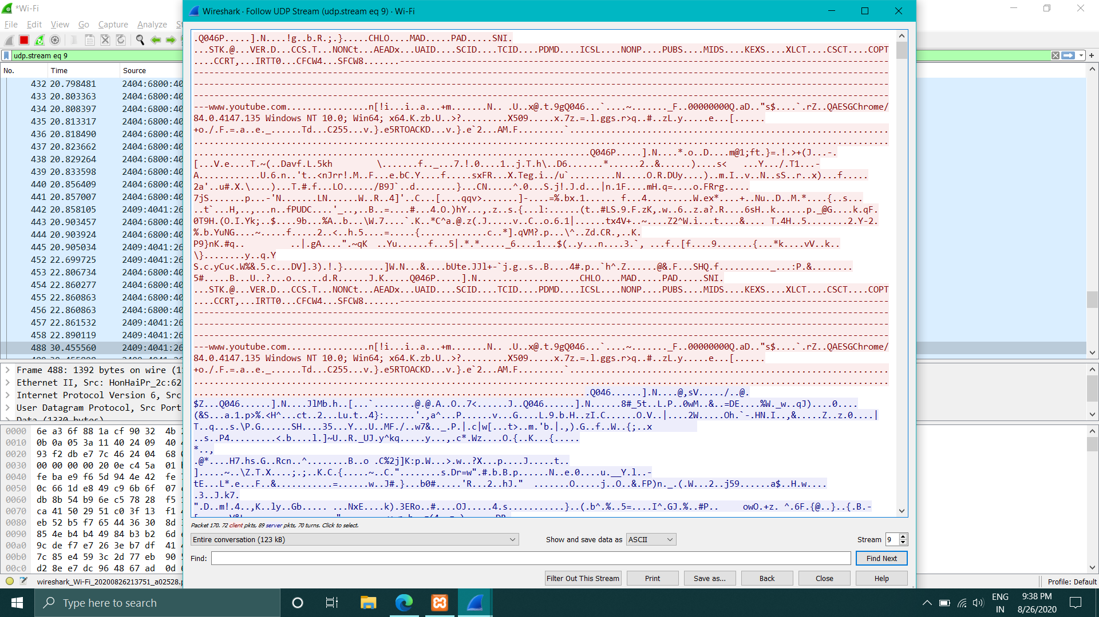

**UDP**

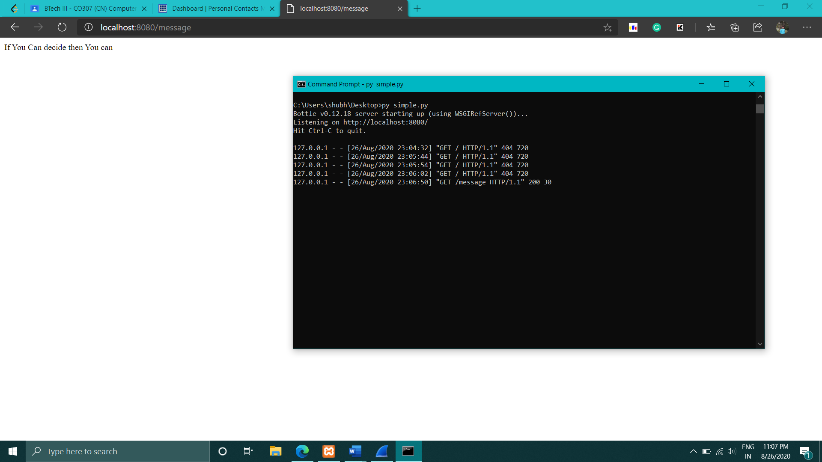

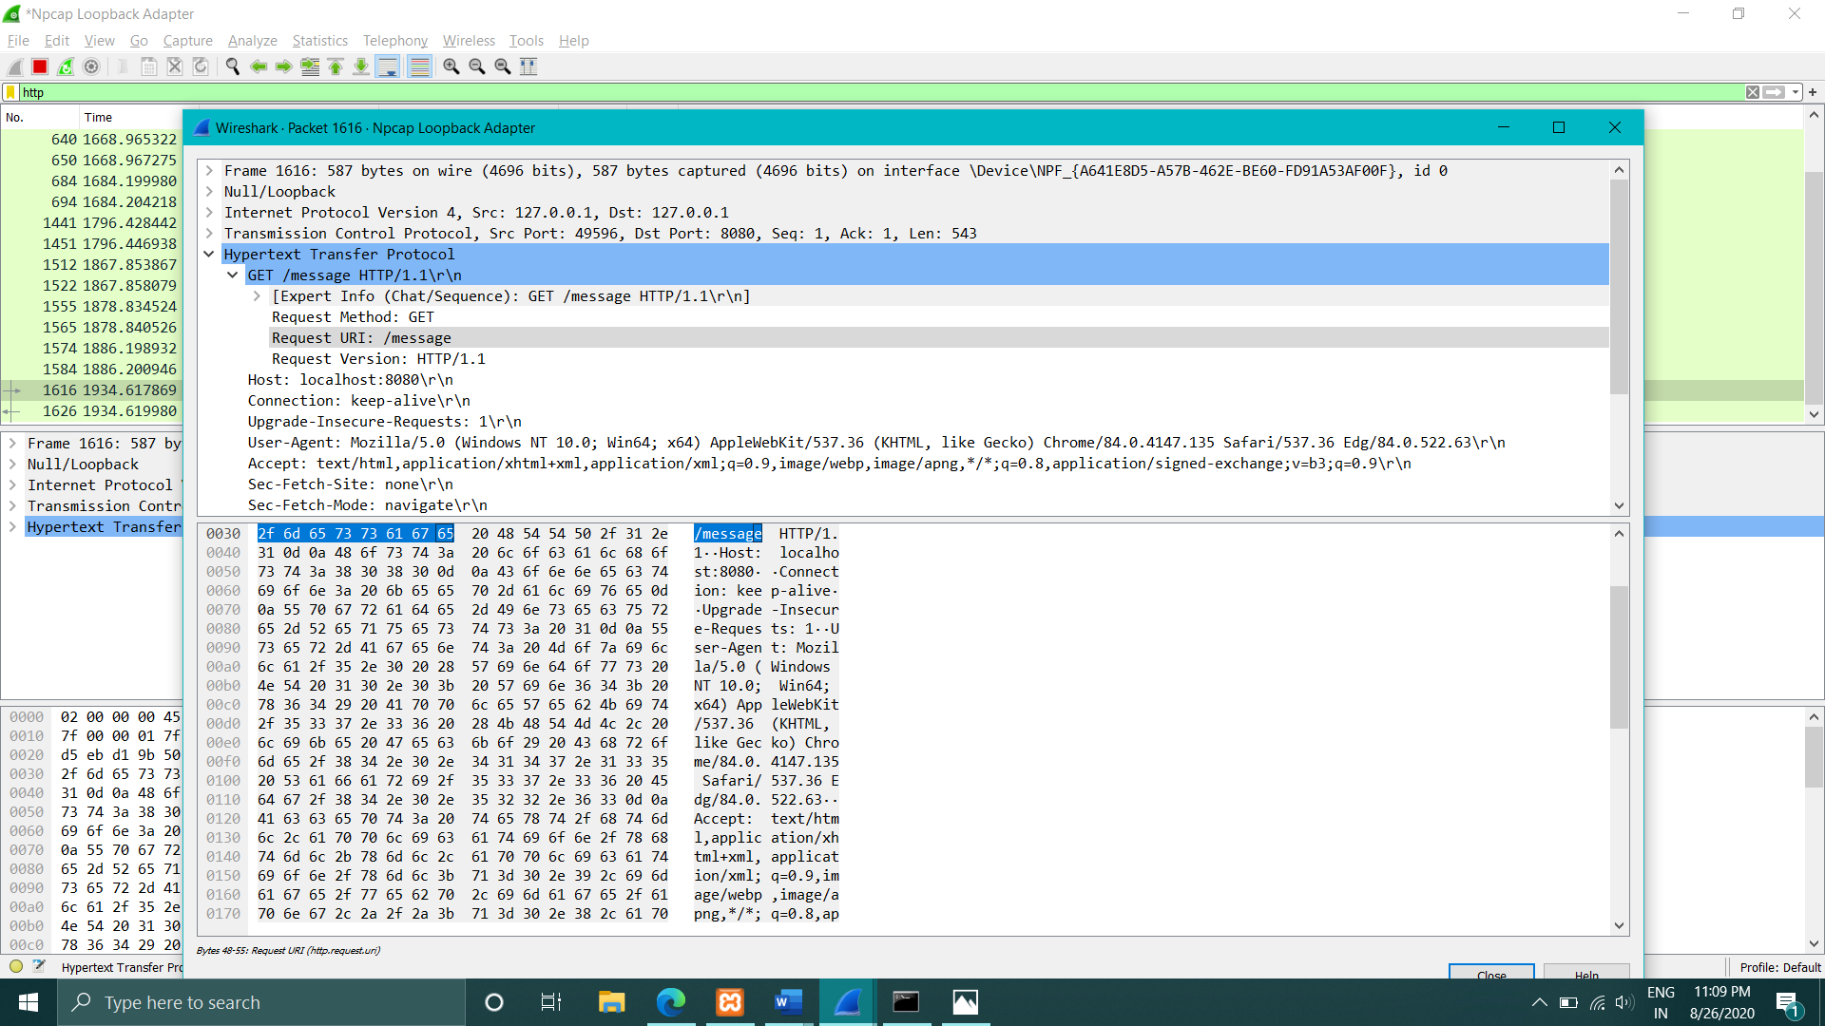

**FOR LOCALHOST**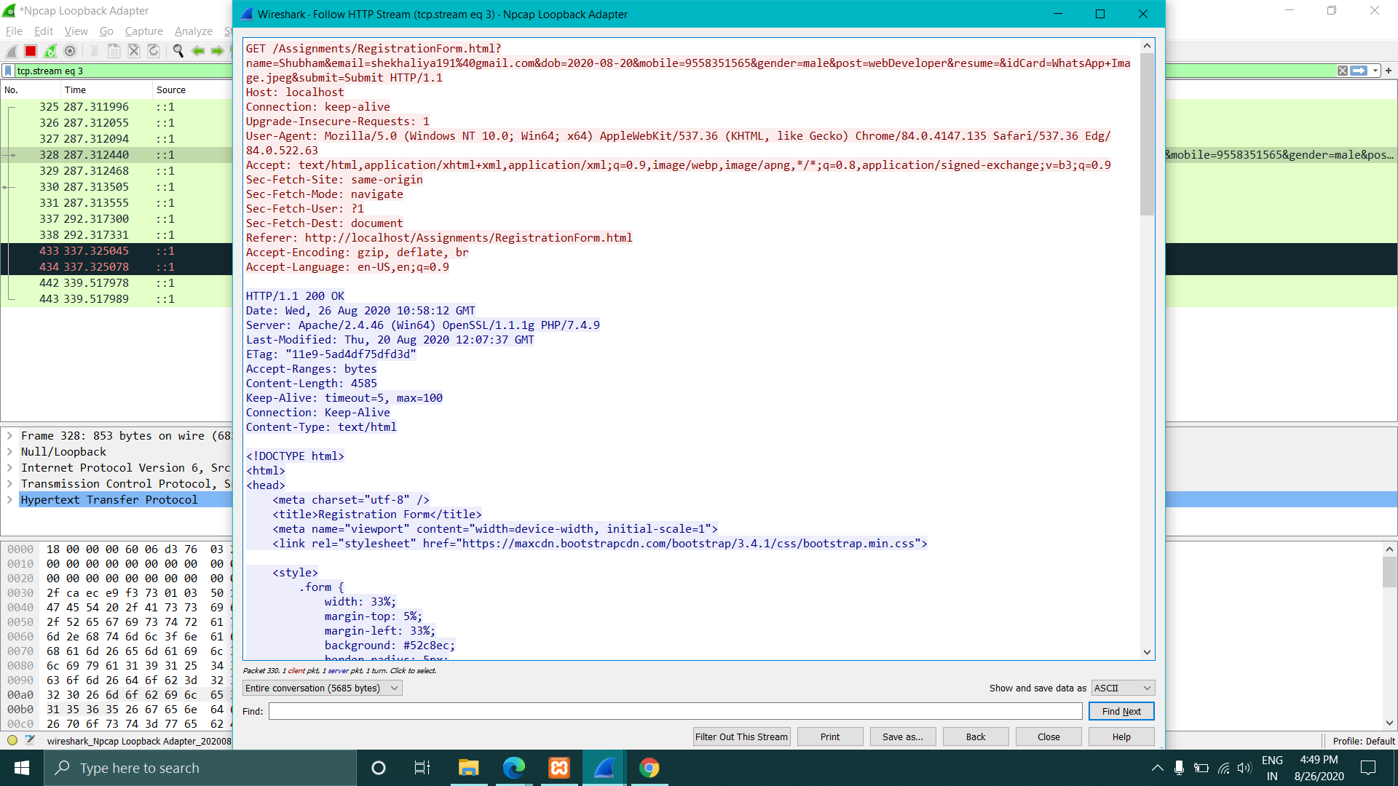

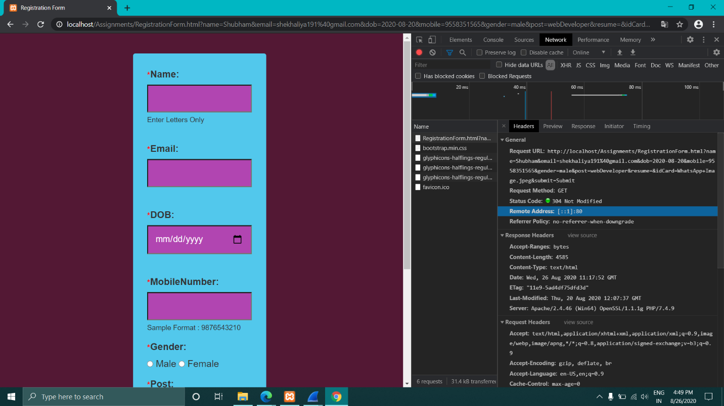

**2 If a packet is highlighted by black, what does it mean for the packet?**

Answer :- . If a packet is highlighted by black, identifies that it is a TCP packet with problems.

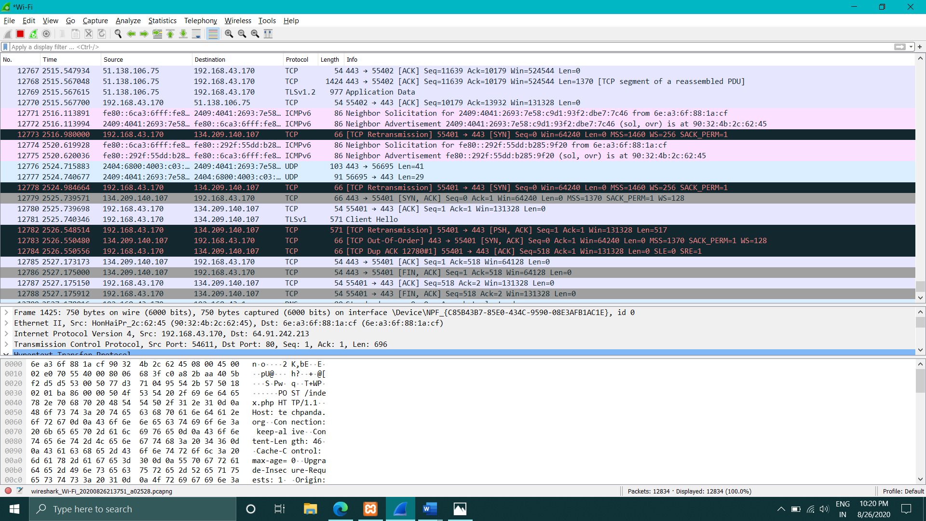

**3** **What is the filter command for listing all outgoing http traffic?**

Answer :- Filter command for listing all outgoing traffic : “http”

**4 Why does DNS use Follow UDP Stream while HTTP use Follow TCP Stream?**

Answer :- TCP uses a three-way handshake before it starts transfer of data, while UDP just blasts away without any formal preliminaries. Thus, UDP does not introduce any delay to establish a connection. This is the principal reason why DNS uses UDP over TCP. DNS would be much rather slower if it ran over TCP. HTTP uses TCP rather than UDP, since reliability is critical for Web pages with text.